its original austerity. Her work resulted in the for mation of a new branch of the Order of Carmel, namely, the Discalced Carmelites, characterized by prayer for the needs of the Apostolate.
The Teresian Reform of Carmel
In her Way of Perfection, Saint Teresa of Jesus writes: “When I began to take the first steps to ward founding this monastery [San José, in Ávi la, the first of her foundations], news reached me of the harm being done [by the religious schisms of the sixteenth century]. The news distressed me greatly, and, as though I could do something or were something, I cried to the Lord and begged Him that I might remedy so much evil. It seemed to me that I would have given a thousand lives to save one soul out of the many that were being lost. . . . All my longing was and still is that since He has so many enemies and so few friends, that these few friends be good ones. As a result, I re solved to do the little that was in my power; that is, to follow the evangelical counsels as perfectly as I could and strive that these few persons who live here do the same. I did this trusting in the great goodness of God, Who never fails to help anyone who is determined to give up everything for Him” (Way of Perfection, Chapter 1).
Thus began the Discalced reform of the Order of the Blessed Virgin Mary of Mount Carmel. Also known as the Teresian reform, after its Moth er-Foundress, the Discalced Carmelites nuns live a life of hidden prayer and penance for Holy Mother Church, especially for priests. Today as in Saint Teresa’s age, “The world is in flames.” To day as in Saint Teresa’s age, Discalced Carmelites nuns are called to spend their life at the foot of the Cross, welcoming redemption for souls who oth erwise might be lost, welcoming grace for priests who need support in their supernatural labors,
welcoming God’s love in reparation for all those who have rejected it. In the words of the nine teenth-century French Carmelite, Saint Thérèse of the Child Jesus and of the Holy Face, the Carmel ite nun is to “be love in the Heart of the Church,” our Mother.
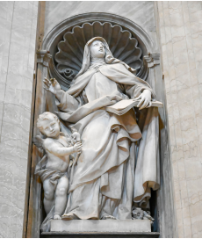Contemplate the Lord who hangs before you on the wood, because He was obedient even to the death of the Cross. He came into the world not to do His own will but that of the Father. . . . Before you, the Redeemer hangs on the Cross, stripped and naked, because He chose poverty. . . . Stand before the Lord, Who hangs from the Cross with His heart torn open. He poured out the Blood of His Heart in order to win your heart. . . . The world is in flames, . . . but above all the flames the Cross stands on high, and it can not be burnt. The Cross is the way which leads from earth to heaven. Those who embrace it with faith, love, and hope are taken up, right into the heart of the Trinity.
-Saint Teresa Benedicta of the Cross, O.C.D. (Edith Stein)
Carmel of Jesus Crucified Muenster, TX
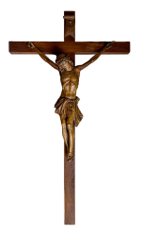We Are Building a
New Monastery
Merry Christmas! We hope this letter finds each of you well and rejoicing in the Nativity of Our Lord. When the Word was made flesh, “He came unto His own, and His own received Him not” (John 1:11). Today in North Texas the situation is very differ
ent. Late in the evening on the Feast of St. Nicho las, we arrived—six Discalced Carmelite nuns––in Muenster, to establish a Carmel in your midst, and how generously and open-heartedly we have been received by you! We know that ultimately, it isn’t just we ourselves whom you are receiving. It is Je sus, Who says in the Gospel: “Whatsoever you do to the least of these, My little ones, you do to Me.” Your reception has been a witness to your lively faith; your hearts are open to the Advent of Christ. May He reward you!
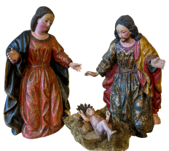
We Invite You to Join Us
We are writing today to invite you to join us in building our new monastery—a dovecot of Our Lady, (as Saint Teresa of Jesus described her Car mels), a little Nazareth, where the life of the Holy Family can be continued in your midst, a citadel where our Heavenly King may retire to find His repose when others turn Him out and treat Him disgracefully.
We have been generously gifted with land north of Muenster on which to build, and have been tempo rarily leased other land on which to live until the new monastery is complete. Now we need to set to work on building a worthy dwelling place for Our Lord, and for this we will need your assistance. We came with some practical household goods, a col lection of books, and our straw-stuffed mattresses, but very few resources beyond these items.
How to Help
The Carmel of Jesus Crucified needs your spiri tual and material support. First, we request your prayers for us and for our efforts, that all be done for the glory of God and the salvation of souls. If salt loses its savor it is not good for anything, as Our Lord says. We are laying our foundations now, not just physically, but spiritually. Pray that we, your new sisters, will remain ever faithful to God’s sum mons. As for our temporal support, both monetary donations and donations of time and skilled labor will be needed as we move forward with building the Carmel of Jesus Crucified.
Donations can be addressed to:
Carmel of Jesus Crucified
P.O. Box 308
Muenster, TX 76252
All donations are tax-deductible under the auspices of the Carmel of Our Lady of Divine Providence, in St. Paul, Minnesota, the established Carmel from which we came. Enabled by your support, the Nuns will soon begin planning the new monastery, to be erected in your midst, and as architectural renderings become available, we will gladly share these with you, so that you can see more clearly the House of God which you are helping to build by your love and prayer and sacrifice. May God reward you!
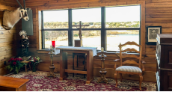The sanctuary in our temporary residence in Muenster, TX.
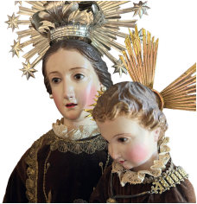
The Order of the Blessed Virgin Mary of Mount Carmel
The Order of the Blessed Virgin Mary of Mount Carmel took canonical shape in the thirteenth century as Latin pilgrims, crusaders, and peni tents settled on the slopes of Mount Carmel and entered into the ancient monastic tradition already established there, following in the footsteps of the Prophet Elijah, who they took as their spiritual Progenitor, and dedicating themselves to the hon or of the Blessed Virgin Mary, Mother of God. Eventually, due in large part to Saracen invasion, hermits had to abandon this cradle of their reli gious life and return to Europe, where the Order adopted a mendicant structure and, due to pres sures coming from city life and the devastations of the Black Plague, eventually lost some of its original austerity. Consequently, in the sixteenth century, Our Lord raised up a Spanish Carmel ite nun, Saint Teresa of Jesus, to reform His Mother’s beloved Carmelite Order, restoring it to

